Work unit

Task description

Task conducted by

Related documents

The following PPE must be worn at all times when conducting this task (delete images for PPE not required):
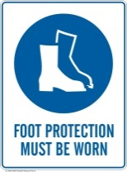 |  | 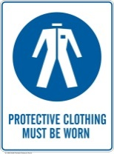 | 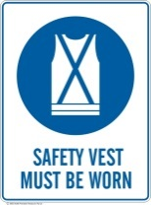 |  |  | 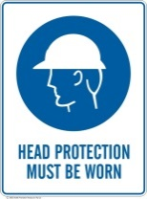 |  | 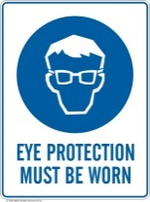 |  | 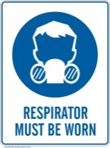 | 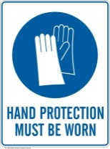 |  | 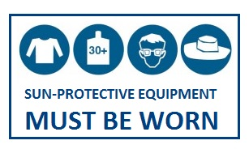  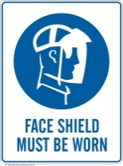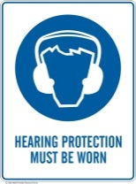

Equipment required

Additional requirements
Work permits required? |  |  |  | Yes | No
Step | Instructions required to perform the task safely |  |  |  |  |  | Risk evaluation  (low, moderate, high, extreme) |  | Hazards  (Hazards associated with task) |  |  | Controls

Reviewed by:
Date | Name | Signature
 | [employee name]
 |  | [Aug 21]

