WHSMP02 – FOR – 10 - Safe Work Instruction (SWI)
Location:(Where work will be done) |  |  |  |  | Date: |  |  |  | Revision:
Task Description:
(Include machine/plant type)
Signed & Approved by Responsible person
(Print Name, Title & Signature)
SWI completed by:
(Print Names & Titles)
Plant, tools, equipment required: |  |  |  | Authority To Operate required?  (If yes, please include details) |  | ☐ No ☐ Yes:
Risk Assessment reference: |  |  |  | Licence or qualification required?  (If yes, please include details) |  | ☐ No ☐ Yes:
Emergency Equipment  (Remove what is not required) | 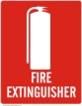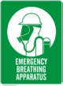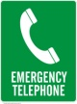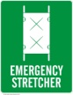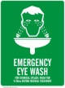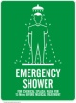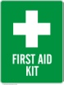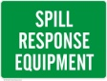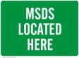
Personal Protective and Safety Equipment:  (Remove what is not required) | 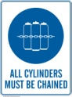      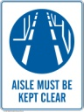  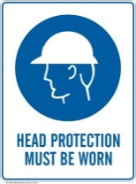    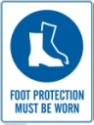  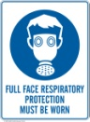  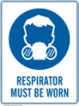  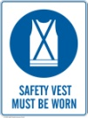  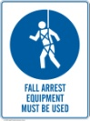  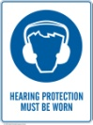  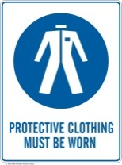  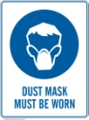      
Is a Permit is required?  (e.g. hot works, confined spaces, ethics) | ☐ No ☐ Yes | Permit Type:

Does this task involve a Critical Risk? (Select what is involved)
Animals | Aviation | Biological agents | Boating | Confined space | Diving | Electricity | Emergency events | Falls | Hazardous substance | Person – vehicle / machinery interaction | Violence and aggression | Lack of Oxygen
☐ | ☐ | ☐ | ☐ | ☐ | ☐ | ☐ | ☐ | ☐ | ☐ | ☐ | ☐ | ☐
Pressurised gas /stored energy | Psychosocial | Radiation | Remote and isolated work | Vehicle operation | Working in and around water | For more information, please visit the Critical Risk framework pages
☐ | ☐ | ☐ | ☐ | ☐ | ☐

Task No. | Tasks  List in sequence, the tasks involved in the work activity (step this out). | Hazards  List the hazards relating to each task. | Controls  Describe what will be done to control the risk. Include reference to specific PPE and work permits as required. | Images / Photos
1
2
3
4
5
6
7
8
9
10

References
Standards, Codes of Practice, Guidance:

SWI consultation and sign on
By signing this SWI I confirm:
- I understand the documented hazards and risk controls associated with this activity and will comply with the control measures for those identified hazards, and
- I have implemented any risk controls I am responsible for.
I will inform my Team Leader & other relevant parties associated with this SWI if the hazards of the job change.

Full Name | Signature | Date

